Player Name: ___________________________________ Age Group: ____________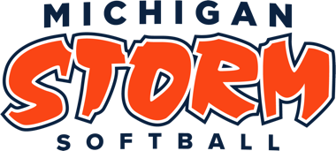
New Player or Returning Player REVISED 8/7/23

Team: ________________________ Coaches Name: ________________________

Uniform #: ___________ Last Name (printed neatly): _____________________________ GRAD YEAR: _________

Parent Signature:_______________________________ Player Signature:____________________________________
(Once a family places their order, there are no exchanges or refunds. All items are custom to each athlete. Any changes will result in additional cost to the athlete’s family)
ITEM | COLOR | SIZE (circle) | QUANTITY | PRICE | TOTAL
Game Jersey | WHITE | YS, YM, YL, AS, AM, AL, AXL, A2XL, A3XL |  | $35.00
Game Jersey | GREY | YS, YM, YL, AS, AM, AL, AXL, A2XL, A3XL |  | $35.00
Game Jersey | NAVY | YS, YM, YL, AS, AM, AL, AXL, A2XL, A3XL |  | $35.00
Game Jersey | ORANGE | YS, YM, YL, AXS, AS, AM, AL, AXL, A2XL |  | $35.00
Game Jersey | Red | YS, YM, YL, AXS, AS, AM, AL, AXL, A2XL |  | $35.00
Practice Jersey | NAVY | YM, YL, YXL, AS, AM, AL, AXL, A2XL |  | $30.00
Softball Visor | Navy or White | One Size Fits all |  | $15.00/ea.
Softball Pants | ORANGE | 22, 24, 26, 28, 30, 32, 34, 36 |  | $45.00
Softball Pants | NAVY | 22, 24, 26, 28, 30, 32, 34, 36 |  | $45.00
Softball Pants | GREY | 22, 24, 26, 28, 30, 32, 34, 36 |  | $45.00
Softball Pants | WHITE | 22, 24, 26, 28, 30, 32, 34, 36 |  | $45.00
Belt | NAVY | One Size |  | $5.00
Belt | ORANGE | One Size |  | $5.00
Belt | WHITE | One size |  | $5.00
Belt | RED | One size |  | $5.00
Game Socks | NAVY | Shoe Size: ________ |  | $7.50
Game Socks | ORANGE | Shoe Size: ________ |  | $7.50
Game Socks | WHITE | Shoe Size:________ |  | $7.50
Game Socks | RED | Shoe Size:________ |  | $7.50
Boombah Helmet | White & Orange | Junior: 6 ¼-7  Senior: 7-7 ¾ |  | $70.00
Boombah Bat Bag | Navy & Orange | Choose Style  A or B |  | A= $100.00  B = $145.00
TOTAL | TOTAL | TOTAL | TOTAL | TOTAL | $

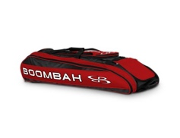
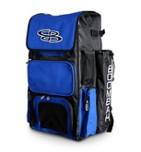
A. Navy/orange colors B. Navy/Orange (This bag is needed for catchers’ equipment)

