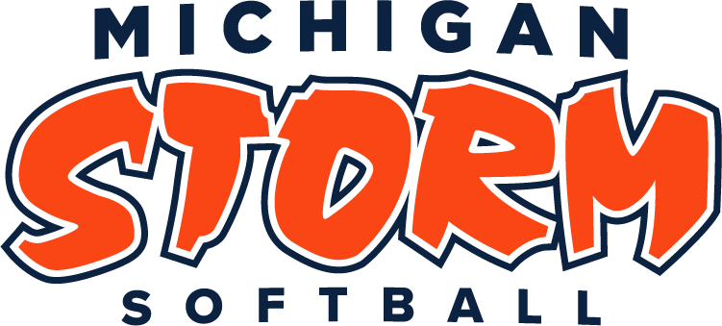 | 2023 - 2024  Sponsorship Form  Girls Softball  Travel Teams ranging in age group  from 9u through 23u

$250 Silver Sponsorship ($100.00 applied towards player acquiring the sponsor)
- Sponsor business name and contact information placed on Michigan Storm website
- Flyers/coupons provided by Sponsor to be distributed to all Michigan Storm families
$500 Gold Sponsorship ($200.00 applied towards player acquiring the sponsor)
- Sponsor business name and website link placed on Michigan Storm website
- Flyers/coupons provided by Sponsor to be distributed to all Michigan Storm families
- Sponsorship banner hung at the Storm Center (banner provided by sponsor)
- 2 Michigan Storm polo golf shirts
$750 Platinum Sponsorship ($300.00 applied towards player acquiring the sponsor)
- Sponsor business name and website link placed on Michigan Storm website
- Flyers/coupons provided by Sponsor to be distributed to all Michigan Storm families
- Sponsorship banner hung at the Storm Center (banner provided by the sponsor)
- Sponsor logo placed on over 500 Storm Summer Classic T-shirts sold at tournament
- 2 Michigan Storm jackets
Thank You for Supporting the Michigan Storm Softball!
Amount Sponsored $___________________ Player/Family Name Requesting Sponsorship:___________________________________
Coaches name/team of player:__________________________________________ Age group:____________
Make Checks Payable to Lakeshore Storm Softball, Inc.
Contact: Deb Sleeman 616-218-9958 sleemandeb@gmail.com www.lsstorm.com
Sponsor Business Name: _____________________________________Company Website:___________________________________
Contact Name:__________________________________ Address: ______________________________________________________
Phone #:___________________________________________Email:_____________________________________________________
Polo Shirt Sizes (indicate M/F size):_____________________________Pullover Jacket Sizes (Men’s):_________________________
(For Gold Sponsorship) (For Platinum Sponsorship)
Michigan Lakeshore Storm Softball, Inc. is a 501(c)3 nonprofit organization. Federal Tax ID# 38-3779772.
Please mail this form to Deb Sleeman, Michigan Storm Director, 10485 Caribou Ct. Zeeland, MI 49464

